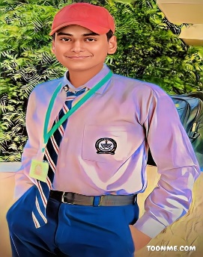

Experience
Jan-2019 to Nov-2022
Computer Operator
- 03 years’ Experience
Software House Skillable Solutions

Feb-2022 to Apr-2023
Graphic Designer
- 01 years’ Experience

Apr-2018to Jan-2023
MS. Office
- 04 years’ Experience

Apr-2021to Apr-2023
Social Media Services
- 02 years’ Experience
Software House Skillable Solutions

PERSONAL DETAILS
Father’s Name : Muhammad Abbas
Surname : Syed (Shah)
Date of Birth : 16-Apr-2005
NIC # : 41304-1919855-3
Domicile : Hyderabad
Marital Status : Single
Religion : Islam
Nationality : Pakistani

MUHAMMAD ILYAS
0319 2674329
ilyasshah4488@gmail.com
Keep to achieve a position in an organization, whose foundation is integrity, strength is people, style is teamwork and goal is excellence, which provides opportunities of self-development, serving efficiently with all the abilities and expertise that I have. 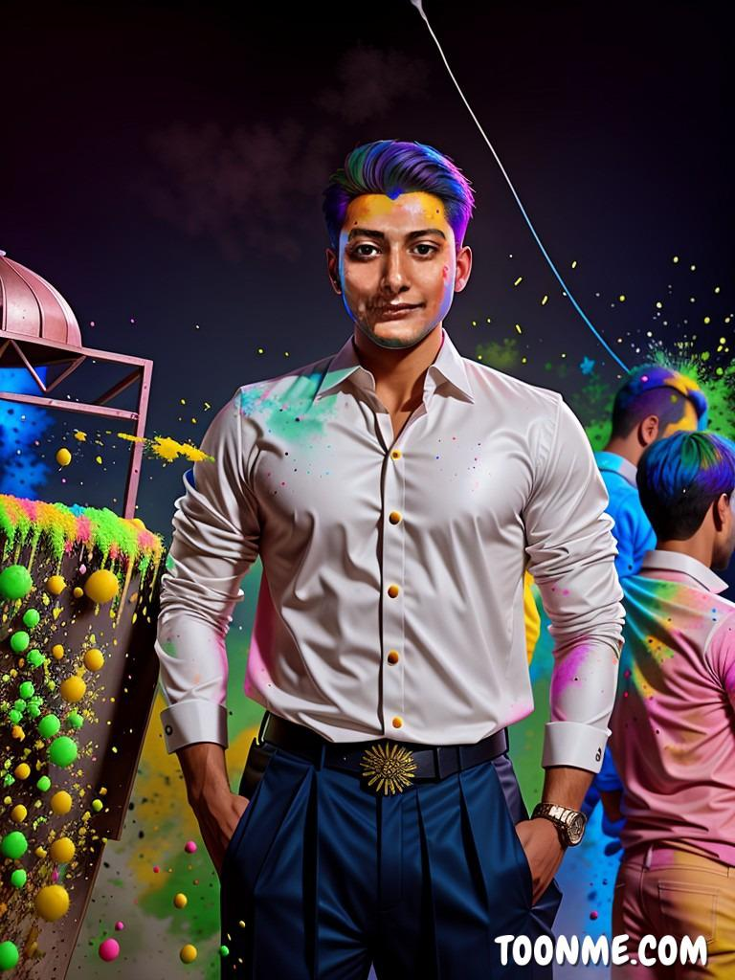

Skills
- 06 Months Course CIT

- Graphic Designer

- Digital Marketer

- Social Media Services

Education
- Matric Pass from B.I.S.E Hyderabad.
- Inter Pass from B.I.S.E Hyderabad

Language
- Urdu

